IndiaRide: Explore India on Wheels

Dr. Rajaram V

Department of Networking and Communications School of Computing

SRMIST, Kattankulathur Campus,

Chennai, India rajaramv@srmist.edu.in

Aditya Singh

Department of Networking and Communications School of Computing,

SRMIST, Kattankulathur Campus,

Chennai, India

as2769@srmist.edu.in

Priyanshu Singh

Department of Networking and Communications School of Computing,

SRMIST, Kattankulathur Campus,

Chennai, India ps9201@srmist.edu.in

*Abstract*— The increasing demand for seamless and cost-effective vehicle rental services across India has led to the development of IndiaRide, a decentralized platform that connects travelers with vehicle owners. This research presents IndiaRide, an online vehicle rental system that allows users to rent cars, bikes, and other vehicles for a specified duration while ensuring secure transactions and verified documentation. The platform enables vehicle owners to list their vehicles with proper documentation, and customers can register with valid authentication credentials to rent a vehicle. The system incorporates online payment mechanisms to facilitate direct transactions between renters and vehicle owners. To enhance security and ensure the integrity of user and vehicle documentation, blockchain technology is proposed as a future enhancement. This paper explores the architecture, functionality, and potential impact of IndiaRide, focusing on its ability to provide a trustworthy and efficient vehicle rental solution for long-distance travelers across India.

Keywords: Vehicle Rental, Online Booking, Blockchain, Authentication, Secure Transactions

# INTRODUCTION

The rapid growth of urbanization and the increasing demand for flexible transportation solutions have significantly transformed the vehicle rental industry. According to recent studies, urban areas are expected to house nearly 68% of the world’s population by 2050, leading to heightened congestion and a pressing need for efficient mobility options. As cities expand and populations rise, traditional modes of transportation often fall short in meeting the diverse needs of commuters and travelers. In this context, IndiaRide emerges as a comprehensive vehicle rental platform designed to connect vehicle owners with customers seeking convenient and accessible transportation options.

The vehicle rental market has seen a paradigm shift with the advent of technology-driven solutions. Ride-sharing platforms have gained immense popularity, offering users the ability to rent vehicles on-demand through mobile applications. However, despite the proliferation of such services, many existing platforms face challenges related to user experience, security, and sustainability. IndiaRide aims to address these challenges by providing a user-friendly interface that simplifies the vehicle rental process while ensuring secure transactions and compliance with legal requirements.

This paper aims to explore the development and implementation of IndiaRide, focusing on its core features, architecture, and the technological innovations that drive its functionality. The platform not only facilitates seamless vehicle rentals but also promotes sustainable transportation by incorporating electric vehicles into its offerings. By addressing the challenges faced by both vehicle owners and renters, IndiaRide strives to enhance the overall user experience while contributing positively to local economies.

One of the key objectives of IndiaRide is to empower vehicle owners by allowing them to monetize their assets effectively. Many individuals own vehicles that are underutilized, leading to wasted resources. By providing a platform where these owners can list their vehicles for rent, IndiaRide creates an opportunity for them to earn income while simultaneously offering customers a diverse range of rental options. This dual benefit fosters a sense of community and encourages responsible vehicle usage.

The significance of this research lies in its potential to provide insights into the evolving landscape of ride-sharing and vehicle rental services in India. As the market continues to grow, understanding user preferences, operational efficiencies, and security measures becomes crucial for ensuring the success of such platforms. This study will also highlight the unique aspects of IndiaRide that differentiate it from existing competitors in the market.

To achieve these objectives, this paper will first review relevant literature on vehicle rental systems and ride-sharing platforms. This literature review will encompass existing studies on user behavior, market trends, and technological advancements in the industry. It will provide a foundation for understanding how IndiaRide fits into this broader context.

Following the literature review, the paper will outline the system architecture and key features of IndiaRide, detailing how each component contributes to a seamless user experience. The architecture will encompass both frontend and backend elements, highlighting technologies used in development and integration with payment gateways for secure transactions.

Additionally, an analysis of implementation challenges will be presented, including issues related to data privacy, regulatory compliance, and user trust. Addressing these challenges is essential for building a reliable platform that meets user expectations while adhering to legal standards.

Ultimately, this research aims to contribute to a deeper understanding of how technology can reshape transportation solutions in urban environments. By examining IndiaRide's approach to vehicle rentals, this study seeks to pave the way for more sustainable and user-centric mobility options that can adapt to the demands of modern society. Through innovative solutions and a commitment to enhancing user experiences, IndiaRide aspires to play a pivotal role in transforming urban transportation dynamics in India..

# LITERATURE SURVEY

The vehicle rental industry has experienced significant transformations due to the integration of digital technologies and online platforms. This literature survey examines key research contributions that highlight the development, functionalities, and challenges associated with vehicle rental systems, particularly in the context of IndiaRide.

One notable study presented in the **International Research Journal of Modernization in Engineering Technology and Science** discusses the implementation of an online platform for vehicle rentals. The authors emphasize the dual goals of streamlining administrative processes for rental firms while providing a user-friendly experience for customers. The platform allows users to browse an extensive inventory of vehicles, refine search results based on criteria like location and features, and manage rental periods efficiently. It also facilitates communication between tenants and rental agencies, showcasing the importance of integrating technology to enhance operational efficiency and customer satisfaction[1].

Another comprehensive survey on vehicle rental systems highlights key features such as real-time availability tracking, booking management, and GPS tracking. The paper discusses how these features contribute to operational efficiency for rental companies while providing a seamless experience for customers. The authors note that user-friendly interfaces are crucial for attracting customers and ensuring repeat business. Additionally, flexible pricing and payment options are emphasized as essential components that cater to modern travelers' needs[2].

A review article published in the **International Journal of Novel Trends and Innovation** analyzes various aspects of car rental websites. It differentiates car rental systems from traditional taxi services, highlighting unique features such as customer autonomy in booking vehicles from anywhere in the world. The paper discusses existing drawbacks within current systems, such as issues related to vehicle quality assurance and customer service, while proposing potential solutions to enhance user experiences[3].

Furthermore, research from IJRASET outlines how online platforms have revolutionized the vehicle rental business by enabling customers to book vehicles digitally and complete transactions online. This shift not only enhances convenience but also expands accessibility to rental services. The study emphasizes that customers can now enjoy greater flexibility in their rental experiences, whether opting for doorstep delivery or visiting physical rental locations[4].

In addition to discussing operational improvements, several studies focus on the sustainability aspect of vehicle rental systems. For instance, research has shown that optimizing fleet management through digital platforms can lead to reduced idle time for vehicles, contributing to lower environmental impacts. This aligns with growing consumer preferences for eco-friendly transportation options[5].

The literature also highlights the importance of customer support features integrated into online vehicle rental systems. Notifications regarding booking confirmations, upcoming returns, and overdue vehicles significantly improve user experiences by keeping customers informed throughout their rental journey[2]. Enhanced customer support is increasingly facilitated by AI-driven chatbots that provide instant assistance for common inquiries.

Moreover, recent advancements have introduced contactless check-in and check-out processes, allowing customers to complete transactions without physical interaction with staff. This shift has become particularly relevant in light of the COVID-19 pandemic, where safety concerns have heightened the demand for contactless services[1]. Digital identity verification and electronic signatures further streamline these processes by ensuring secure transactions while reducing paperwork.

Overall, this literature survey reveals a clear trend towards digitization in the vehicle rental industry, driven by consumer demand for convenience and efficiency. As competition intensifies among service providers, understanding user preferences and addressing operational challenges will be crucial for success. Future research should focus on exploring innovative technologies such as artificial intelligence (AI) and machine learning (ML) to further enhance personalization in vehicle rentals, ultimately leading to improved customer satisfaction and loyalty[6][7].

This survey serves as a foundation for understanding how IndiaRide can leverage these insights to develop a robust vehicle rental platform that meets modern demands while addressing existing gaps in the market. By integrating advanced technologies and maintaining a focus on user-centric design, IndiaRide aims to reshape the vehicle rental landscape in India, catering effectively to both vehicle owners and renters alike.

# METHODOLOGY

The methodology for the IndiaRide vehicle rental project encompasses a structured approach to system development, focusing on user needs, technological integration, and operational efficiency. This section outlines the key phases involved in the development of the IndiaRide platform, including requirement gathering, system design, implementation, testing, and deployment.

*1. Requirement Gathering*

The first phase involves comprehensive requirement gathering to identify the needs of various stakeholders, including vehicle owners, customers, and administrative staff. This process employs a combination of qualitative and quantitative research methods:

Surveys and Questionnaires: Online surveys will be distributed to potential users to gather insights on their preferences, expectations, and pain points regarding vehicle rental services. Questions will focus on features they consider essential, pricing models, and their preferred modes of communication.

Interviews: In-depth interviews with vehicle owners and rental agency staff will provide qualitative data on operational challenges and expectations from a digital platform. These discussions will help identify specific functionalities needed to streamline processes.

Market Analysis: A thorough analysis of existing vehicle rental platforms will be conducted to understand industry trends, competitive features, and gaps that IndiaRide can address. This analysis will inform feature prioritization and differentiation strategies.

*2. System Design*

Based on the gathered requirements, the next phase involves designing the system architecture and user interfaces:

System Architecture: A modular architecture will be developed to ensure scalability and maintainability. The architecture will include components such as:

Frontend: User interface for customers and vehicle owners.

Backend: API services for handling business logic, user authentication, and data management.

Database: A relational database management system (RDBMS) for storing user profiles, vehicle listings, bookings, and transaction records.

Payment Gateway: Integration with secure payment processors for handling transactions.

User Interface (UI) Design: Wireframes and prototypes of the user interface will be created using design tools like Figma or Adobe XD. These prototypes will undergo usability testing with potential users to gather feedback on navigation flow, layout, and overall experience.

*3. Implementation*

The implementation phase involves developing the platform based on the finalized design:

Technology Stack: The IndiaRide platform will be built using a modern technology stack that includes:

Frontend: Html, CSS, Javascript for building responsive user interfaces.

Backend: Node.js with Express.js for creating RESTful APIs.

Database: MySQL for data storage.

Payment Processing: Integration with payment gateways such as Stripe or PayPal for secure transactions.

Agile Development: An Agile methodology will be adopted for iterative development. Sprints will be planned to implement features incrementally while allowing for continuous feedback from stakeholders.

*4. Testing*

Testing is a critical phase to ensure the platform's functionality, security, and performance:

Unit Testing: Individual components of the application will undergo unit testing to verify that each function operates as intended.

Integration Testing: The interactions between different modules (e.g., frontend-backend communication) will be tested to ensure seamless integration.

User Acceptance Testing (UAT): A group of end-users will participate in UAT to validate that the platform meets their needs and expectations. Feedback from this phase will guide any necessary adjustments before launch.

Security Testing: Conducting security assessments to identify vulnerabilities in the application is essential. This includes penetration testing and ensuring compliance with data protection regulations.

*5. Deployment*

Once testing is complete and all issues are resolved, the final phase involves deploying the IndiaRide platform:

Cloud Deployment: The application will be hosted on a cloud platform (e.g., AWS or Azure) to ensure scalability and reliability. Continuous integration/continuous deployment (CI/CD) pipelines will be established for efficient updates.

Monitoring and Maintenance: Post-deployment monitoring tools will be implemented to track system performance, user activity, and error logs. Regular maintenance schedules will be established to address any emerging issues promptly.

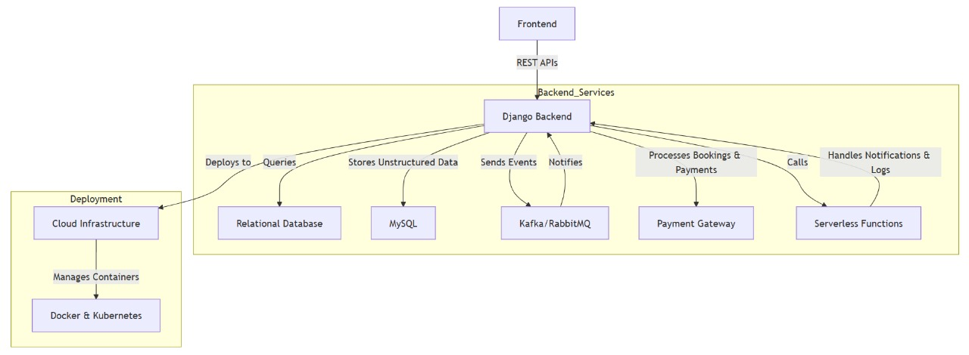

Fig.1. Architecture Diagram

# RESULTS AND ANALYSIS

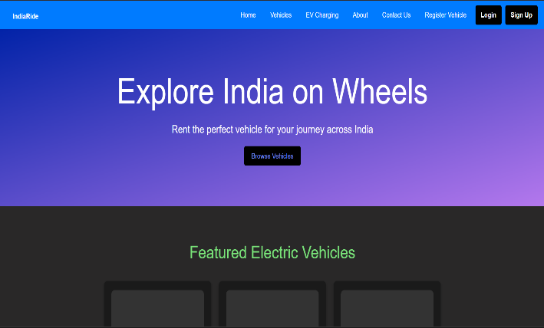

Fig.2. Dashboard

The IndiaRide dashboard is designed to provide users with a seamless and intuitive experience while accessing vehicle rental services. The dashboard features a user-friendly interface that includes essential functionalities such as login and signup options for easy account management. Users can register their vehicles for rental, ensuring a streamlined onboarding process for vehicle owners. Additionally, the dashboard showcases a selection of available vehicles, allowing customers to choose their preferred options based on various criteria. A dedicated section for EV charging stations promotes sustainability by helping users locate nearby charging facilities. Finally, the About Us section provides insights into the IndiaRide mission and values, fostering trust and transparency with users.

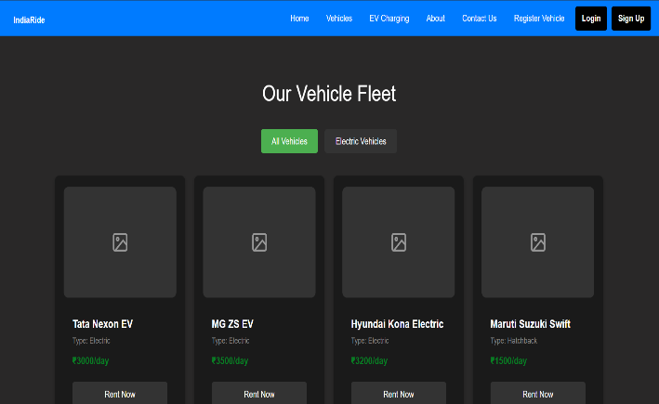

Fig.3. Vehicle section

##### 

Fig.4.Electric vehicles section

IndiaRide offers a diverse fleet of vehicles, including conventional gasoline-powered cars for everyday use and eco-friendly electric vehicles (EVs) that promote sustainable transportation. This variety caters to different customer preferences, ensuring flexibility and convenience while encouraging environmentally responsible choices for modern commuters.

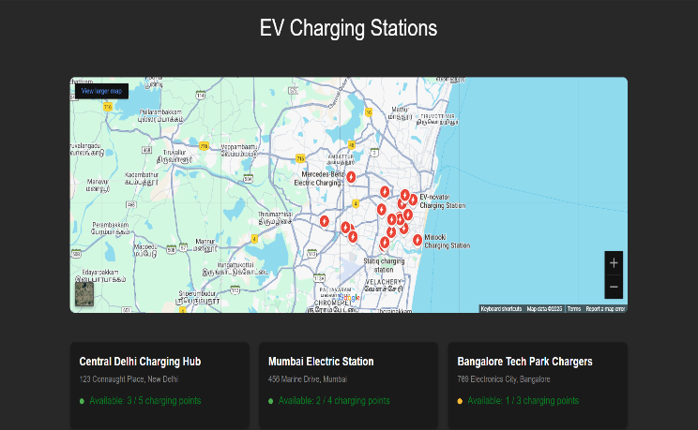

Fig. 5. EV_Charging stations

IndiaRide integrates Google Maps to display nearby EV charging stations, providing real-time availability and location details. Users can easily find charging options, view station information (like plug types and speeds), and add charging stops to their routes, ensuring a seamless and efficient experience for EV drivers.

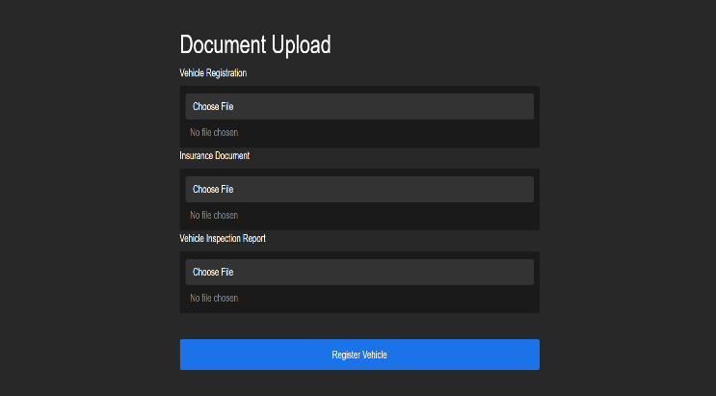

Fig.6. Document upload section

# CONCLUSION

The IndiaRide vehicle rental platform represents a significant advancement in the transportation landscape, addressing the evolving needs of modern commuters and vehicle owners. By integrating advanced technologies and user-centric features, such as seamless registration, diverse vehicle options, and real-time access to EV charging stations, IndiaRide enhances the overall rental experience.

The platform's commitment to sustainability through the inclusion of electric vehicles not only caters to environmentally conscious consumers but also aligns with global efforts to reduce carbon emissions. Additionally, the user-friendly dashboard fosters transparency and trust, encouraging more individuals to engage with the service.

As urbanization continues to rise and mobility demands evolve, IndiaRide is well-positioned to adapt and grow within this dynamic market. Future enhancements, including AI-driven personalization and expanded service offerings, will further solidify its role as a leader in the vehicle rental industry. Ultimately, IndiaRide aims to create a more efficient, accessible, and sustainable transportation solution that benefits both users and the environment.

# FUTURE SCOPE

The future scope of the IndiaRide vehicle rental platform is promising, driven by emerging trends and technological advancements in the automotive and rental industries. As the demand for flexible, sustainable, and user-friendly transportation solutions continues to grow, IndiaRide is well-positioned to capitalize on several key areas:

Integration of Blockchain Technology

As IndiaRide looks to the future, the integration of blockchain technology presents a transformative opportunity to enhance the platform's security, transparency, and efficiency. Blockchain, known for its decentralized and immutable nature, can significantly improve various aspects of vehicle rental services.

Expansion of Electric Vehicle (EV) Fleet:

With the increasing focus on sustainability, IndiaRide plans to expand its fleet of electric vehicles. This aligns with global trends toward eco-friendly transportation options, catering to environmentally conscious consumers. The integration of EV charging stations on the platform will further support this initiative, ensuring that users have convenient access to charging facilities.

Enhanced Digital Booking Experience:

As online bookings become the norm in the car rental industry, IndiaRide will continue to improve its digital booking platform. Enhanced functionalities, such as contactless check-in/check-out processes and mobile app integration, will streamline reservations and transactions, providing a seamless experience for users.

Implementation of Subscription Models:

To meet the growing demand for flexible vehicle ownership options, IndiaRide may explore subscription-based models that allow users to rent vehicles for extended periods without long-term commitments. This approach can attract a broader customer base seeking convenience and flexibility in their transportation choices.

Smart Vehicles and Connected Services:

The future of vehicle rentals lies in smart cars equipped with advanced features such as GPS navigation, real-time tracking, and remote diagnostics. By incorporating connected vehicle technology, IndiaRide can enhance safety, monitor vehicle health, and provide valuable data insights for operational efficiency.

|  |
| --- |
| References |
| [1]. F. Y. H. Ahmed, E. B. Hazlan and M. I. Abdulla, "Enhancement of Mobile-Based Application for Vehicle Rental," *2021 IEEE 11th IEEE Symposium on Computer Applications & Industrial Electronics (ISCAIE)*, Penang, Malaysia, 2021, pp. 163-168, doi: 10.1109/ISCAIE51753.2021.9431820. |
| [2]. S. Hu, H. Lin, K. Xie, X. Chen and H. Shi, "Modeling users' vehicles selection behavior in the urban carsharing program," 2018 21st International Conference on Intelligent Transportation Systems (ITSC), Maui, HI, USA, 2018, pp. 1546-1551, doi: 10.1109/ITSC.2018.8569386 |
| [3]. T. Vinod, N. Kumaresan, I. Gugan, S. Dhanasekaran, K. Ramprathap and P. Chinnasamy, "Online Automobile Rental and E-Marketplace with Augmented Reality (AR)," *2022 International Conference on Advancements in Smart, Secure and Intelligent Computing (ASSIC)*, Bhubaneswar, India, 2022, pp. 1-5, doi: 10.1109/ASSIC55218.2022.10088370. |
| [4]. K. Hara, M. Teramoto and M. Takayama, "The electric vehicle sharing demonstration: the ITS/EV project urban rent-a-car system in the Yokohama Minato Mirai 21 area," *Proceedings of the IEEE Intelligent Vehicles Symposium 2000 (Cat. No.00TH8511)*, Dearborn, MI, USA, 2000, pp. 116-121, doi: 10.1109/IVS.2000.898328. |
| [5]. S. Thapa, S. R. Sahoo, M. Patra and A. Gupta, "A Novel Cost-Aware Load Balancing Algorithm for Road Side Units in Internet of Vehicles," *2022 18th International Conference on Network and Service Management (CNSM)*, Thessaloniki, Greece, 2022, pp. 359-363, doi: 10.23919/CNSM55787.2022.9964580. |
| [6]. P. -Y. Chang and H. -Y. Lin, "The Comparison of the Cost Effection on Pick up and Delivery, and Traditional Distribution Center Vehicle Routing," *2017 International Conference on Industrial Engineering, Management Science and Application (ICIMSA)*, Seoul, Korea (South), 2017, pp. 1-5, doi: 10.1109/ICIMSA.2017.7985608. |
| [7]. K. Hara, "ITS for rent [intelligent transport systems]," in *IEEE Intelligent Systems and their Applications*, vol. 15, no. 5, pp. 84-85, Sept.-Oct. 2000, doi: 10.1109/5254.889111. |
| [8]. S. Patil, D. Adsul, S. Desale and K. Gandole, "Smart Vehicle Rental Application using Blockchain and IoT," *2022 International Conference on Smart Generation Computing, Communication and Networking (SMART GENCON)*, Bangalore, India, 2022, pp. 1-6, doi: 10.1109/SMARTGENCON56628.2022.10084014. |
| [9]. N. Jeba, N. Harishkumar, M. Yogeshwaran and M. A. Kumar, "Online Vehicle Rental System to Enhance Commutation," *2021 International Conference on Advancements in Electrical, Electronics, Communication, Computing and Automation (ICAECA)*, Coimbatore, India, 2021, pp. 1-5, doi: 10.1109/ICAECA52838.2021.9675672. |